**Sheet 8**

Abishek Kumar

Ravikant Tyagi

Erce Can Balcioglu

8.1

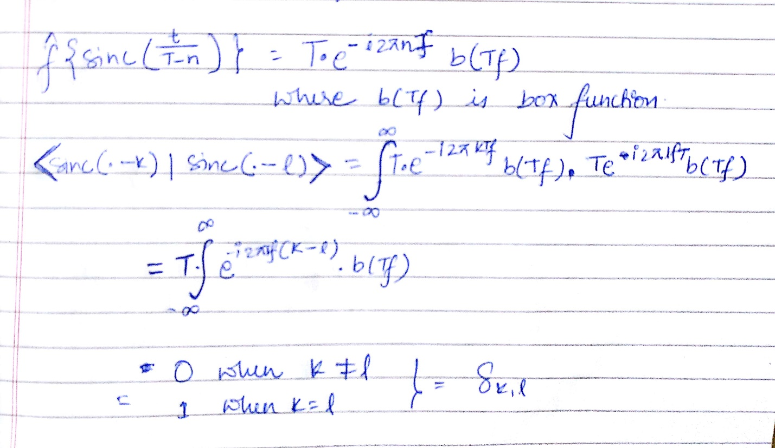

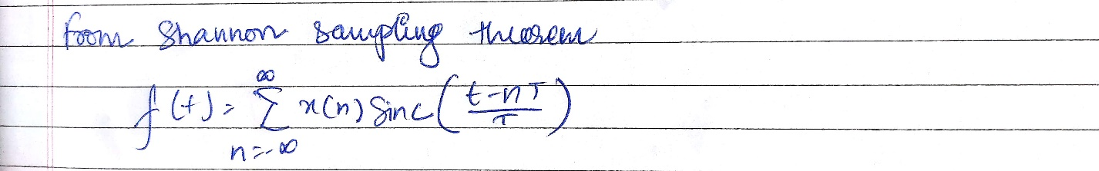

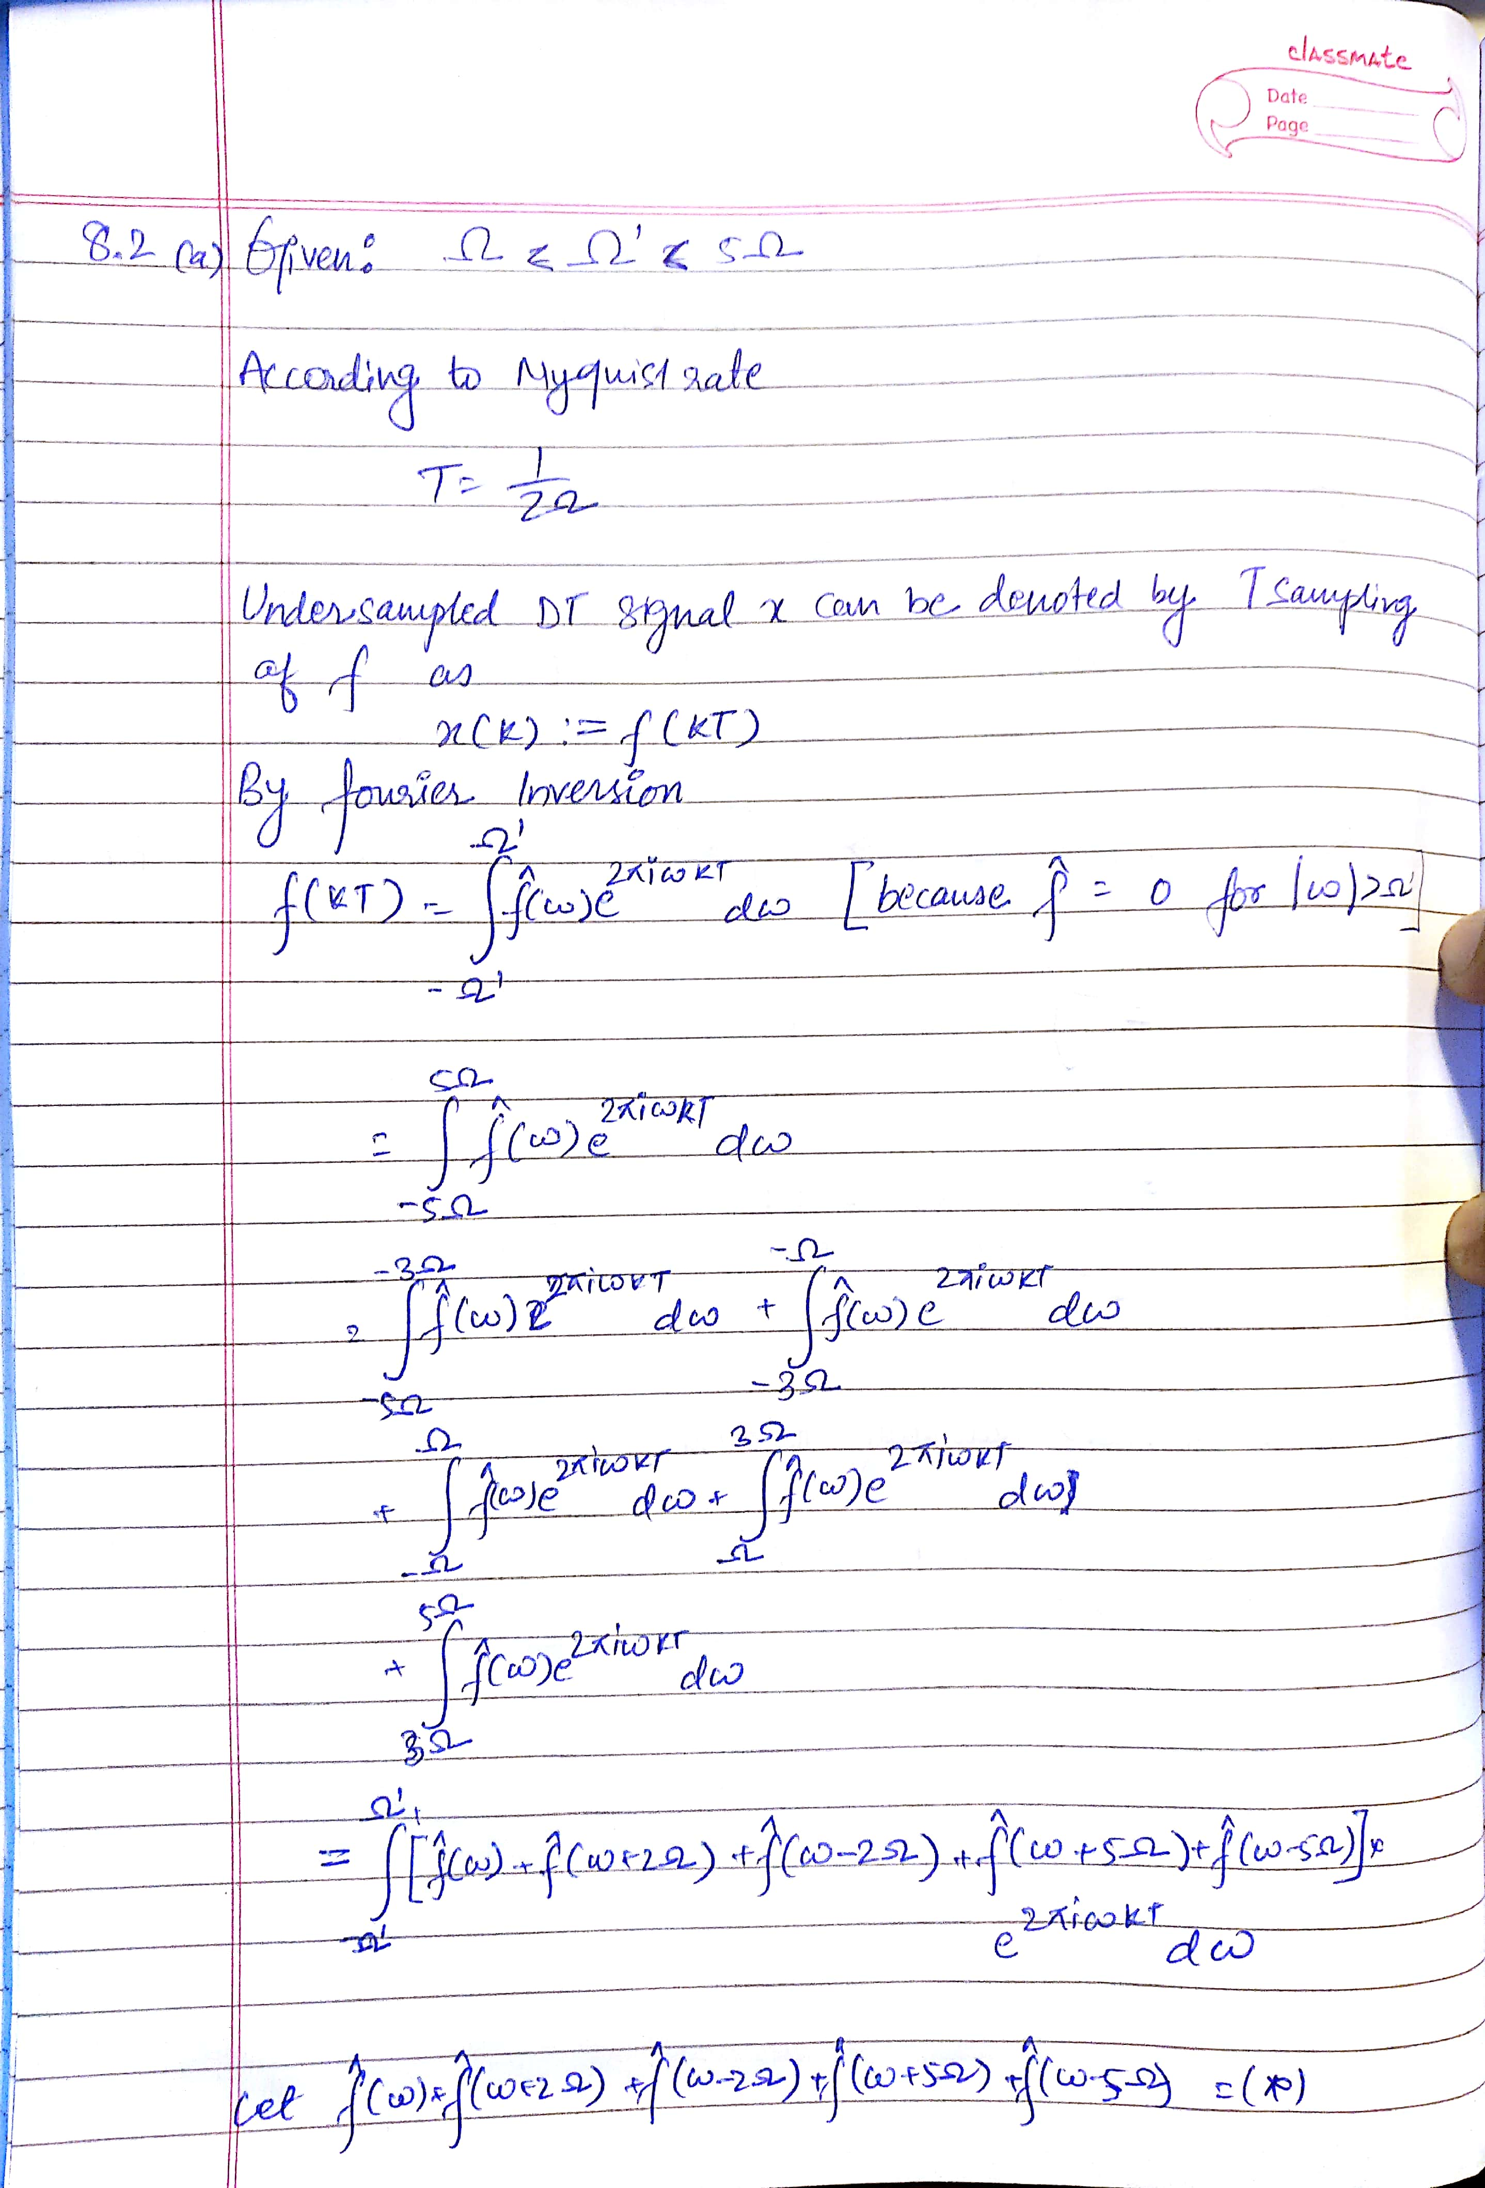

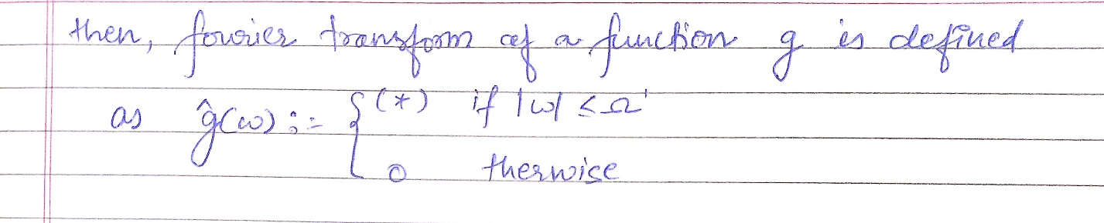

8.2 (b)

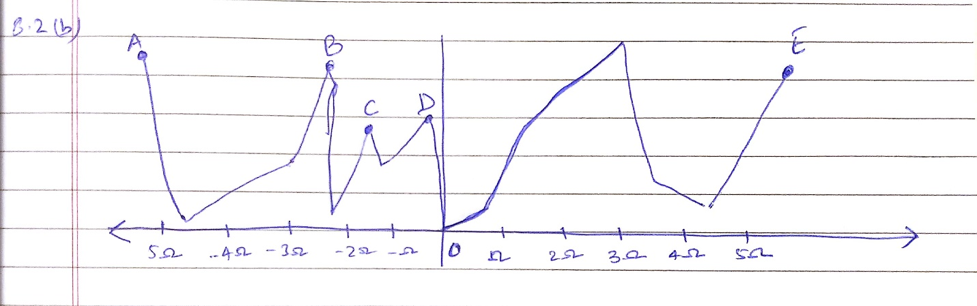

8.3 Plot:

